The Importance of writing before reading; How Montessori materials and curriculum support this learning process

By
Tahzeem Ryan

A Master’s Paper
Submitted in Partial Fulfillment of
The Requirements for the Degree of
Master of Science in Education – Montessori

___________________________________
Advisor

___________________________________
Date

University of Wisconsin – River Falls
2015

Abstract
The Importance of writing before reading; How Montessori materials and curriculum support this learning process
This action research examines the benefits of writing before reading and documents how the Montessori materials and method support students to use writing as a foundation for learning to read. During a six month period, I documented and observed the progress of my students in reading and writing. I chose six case studies representing various ages and both genders, and documented the learning journeys of these children from writers to readers. Data from observations and work samples were collected in the spring and fall for each of the six students. Analysis of data revealed that there were many things that all six of the children had in common, despite their varied ages and genders. The foremost of these was significant progress in their language development. My analysis of the class as a whole indicated to me that the students, over time, chose works that were more directly related to reading and writing. It also revealed that the children were showing an increased interest in reading and writing, even outside of the school environment. My research led me to conclude that it is beneficial to teach writing before reading because of the efficiency, effectiveness, and—most importantly—the way that it engages the students. It builds up their self-esteem while also motivating them to achieve more and more.

Key words: Montessori, sensitive periods, reading, writing, efficient, language, writing before reading
“A child does not read until he receives ideas from the written word” Maria Montessori, Discovery of the Child, p 229).

Introduction
Maria Montessori discovered that children have a sensitive period for language, and it is at this time the child needs to be exposed to language, otherwise the child’s attainment of language will never be as successful as it potentially could have been. Many of the concepts and methods we teach in Montessori seem like great ideas from the moment they are first explained to us. “Of course, “we say, “that makes perfect sense.” However, when beginning my studies, one thing that stood out to me as odd was the concept of teaching writing before reading. Generally accepted wisdom tells us that one cannot write until after one has learned words by reading them. For this reason, I was immediately enchanted by this idea. I asked myself: How can a child write without having learned to read first? How could it be beneficial to approach such an important part of learning from this angle? As I delved into the theories behind this approach, it started to make sense. And then when I saw it in action in the classroom, I was astounded.
When asked to explain Montessori, I am often not sure where to start. I describe the mixed age classroom and the independence and freedom the children have to choose their own work. When I mention to others that almost all of my students are able to read by the time they are five, or in kindergarten, they are astounded. This fueled my interest in understanding how the Montessori curriculum is able to support each child to ensure that most are able to read by their kindergarten year. With many of my students who move on to public school after being in my Montessori Children’s House classroom for two or three years, there is a concern that children will be bored in traditional elementary classroom unless invited to challenge themselves with more and more advanced reading material as they move along their academic journey.
Maria Montessori discovered that introducing writing before reading is the most efficient and effective way for students to learn how to read. She also discovered an “explosion into writing” occurs before reading- before the child can ever read what he/she has written. Traditional schools teach the students the alphabet and many key words before an expectation of writing. If we break down the progression of learning to read, the very first step is the process of matching letters with sounds. It is simply an exercise in rote memorization. However, if children learn to read first, they are going through the steps of working out words that someone else has written. Although this child may be familiar with some letters and key words that child will not feel the same sense of familiarity and ownership of the letters and sounds as a child who is introduced to writing first. For the child who writes first these are their own words and letters, and they can arrange them in any order they desire. Then when they begin to read, they recognize these letters with which they are already familiar. It is an organic process, and I have found that children are most successful when reading and writing are intertwined in this way.
I have seen the great pride so many of my nonreaders take when they copy words or write their name—that pride in their work, and sense of accomplishment they achieve. This all contributes to their love of learning, and the beauty of Montessori takes place. I was amazed by this phenomenon many students would be suddenly and seamlessly able to read. One day they were not able to, and the next day they were. This also takes the pressure off the child as they unconsciously are learning to read without the knowledge that they are doing so.
Literature Review
“Today in the United States, the goal of education is to ensure that every child becomes literate” (van Kleeck, Schuele, 2010, p. 342). Presently, accessibility for education in America has broadened, as well as what it means to be literate. Today, the definition of literacy has evolved from the sole criteria of being able to read; to expecting students to have a much wider foundation of knowledge and higher-level skill sets. “Current practices in preschool, have broadened developmentally appropriate practice for preschoolers to include implicit and explicit pre-literacy instruction targeting oral language, phonological awareness, print awareness, and alphabet knowledge” (van Kleeck et al, 2010, p. 341). This statement impacts the children and teachers of our future because they are responsible for acquiring more skills earlier in the context of “literacy.” The Montessori curriculum introduces writing before reading, whereas the traditional school model introduces children to reading before writing. It is important to note that there is a spectrum and many traditional classrooms that support a balanced literacy approach are inviting “kid writing” or “phonetic writing”, after some phonics and sight word experience in Kindergarten and Grade 1. However, these classrooms do not have the specific literacy support activities introduced at an earlier age that characterize the writing before reading Montessori environment.
Maria Montessori said,
“Writing develops easily and spontaneously in a little child in the same way as speech, which is also a motor translation of sounds that have been heard. Reading on the other hand, forms a part of an abstract intellectual culture. It interprets ideas acquired by graphic symbols and is acquired only later.” (Montessori, 1967,p 199)
Writing before reading is a more efficient way to teach the child in a successive, unconscious and pressure free manner. The child is able to familiarize themselves with the letters through writing, and then put those letters together to make words and start reading. Once the child has been introduced to a handful of letters and their sounds including a vowel, they are empowered to write purposefully.
Presently, school accessibility is available to a wider variety of children and the expectation of success within the education system is vital to the future success of the child (Van Kleeck et al, 2010, p.344). Children and educators have a higher expectation for success, resulting in more pressure for the child to be academically ready in order to be successful. The Montessori Method gives the child the tools to be successful and the opportunity to become literate at an early age by introducing specific materials at specific stages of development. Dr. Maria Montessori observed that the importance of introducing language, specifically reading and writing, to a young child is essential in order to utilize the sensitive period of the child. She also observed that this creates a concrete foundation of knowledge within the child, as well as instilling a love of learning. Dr. Maria Montessori created the Montessori curriculum based on the child’s needs. Her scientific observations of learning processes, and how the child interacts with their environment and materials, are the basis of the Montessori curriculum.
“The hand of a child of six or seven has already lost its precious period of sensitivity to movement. This delicate little hand has left behind that blessed period in which its movements were coordinated. It is therefore condemned to make unnatural and painful efforts to acquire new models of operation.” (Montessori, 1967, p 204)
The Montessori curriculum allows the child to explore and channel their creativity through writing, permitting her a variety of educational advantages. The Montessori curriculum uses a specific set of materials in order to introduce language to the child, both directly and indirectly. When the children enter the Children’s House at the age of three, they are immediately put to work—work that is purposeful and enjoyable to the child. They are first introduced to practical life activities, such as sorting, beading, pouring, and the use of tools, to aide in mastering the pincer grip. Practical life activities also include care of the environment, which introduces structure and order to the child. Exercises in grace and courtesy teach acceptable social behavior (Richardson, 1997, p. 244). All of these activities help the children develop good gross and fine motor coordination, which is indirectly preparing the child for reading and writing.
The sensorial materials are designed to “educate the senses,” allowing the child to create and understand order and sequence when working with the materials. “Then they learn to contrast, to compare and match, to discriminate, to distinguish different sense impressions and to put them in some sort of order through the gradations of quality” (Richardson, 1997, p 245). Richardson is illustrating the systematic progression to support learning with the materials, and how the materials introduce the child to the whole concept before breaking it down into parts. The teacher first introduces preparatory exercises, such as sound games and work with the metal insets. Once the child is able to understand and use the exercises in the practical life and sensorial area, the teacher introduces materials that directly introduce reading and writing to the child. These include the sandpaper letters, metal insets, movable alphabet, and object boxes. This successive exposure to reading and writing is an effective way for the child to express her thoughts, allowing for a creative channel of expression that is individual to that child (Johnstone, 2001). Creative writing instills pride in the child and gives him a positive outlook on reading and writing, giving him an opportunity to use language in a meaningful context (Soundy, 2003). Writing also allows the child to work on his or her pincer grip, which in turn can increase fine motor skills and attention span. This allows the child more opportunity for success within the classroom (Graham, 2010) Maria Montessori observed that children experienced an explosion of writing where the child just wanted to keep writing, even if the letters didn’t form words. Children familiarized with language at an early age through exposure to letter sounds, a variety of literature, and the opportunity to express their ideas, will write pages and pages, even if the letters or words don’t make sense. This experience instills pride, allowing children to make mistakes without being afraid (Johnstone, 2001).
Montessori education introduces language at a very early age, using phonetics to teach the letters of the alphabet. This permits the child to identify the letter with the sound first, allowing the child to sound out words and begin to recognize letters in other contexts. Each specific set of materials within the Montessori curriculum can be adapted to fit the needs of the specific child, using a variety of strategies such as naming games, visual and conceptual matching, and sorting activities (Soundy, 2003). The Movable Alphabet is a core material in the language Montessori curriculum. The mini lessons contained within it are tailored and meaningful, which forms the stairway of knowledge, as Montessori described the structured lessons (Woods, 2002). Once exposed to language though these materials, the child is able to use the language in a meaningful context and use it as an avenue to express her thoughts and ideas. Dorathy Ohlhaver noticed that “our young children come to us with the syntax of their language already formed and can communicate thoughts if we are willing to listen” (Ohlhaver, 2001, p. 36). Teachers have the opportunity to provide a positive and successful relationship between reading and writing and the child, in order for the child to maintain and ensure the productive educational experiences of his academic journey.
Exposure to a variety of literature is essential to inspire the child to borrow ideas and help them channel and express their thoughts and creativity through language. “Children need several genres of literature, like picture books, fiction, nonfiction, fantasy, poetry, and stories about cultures and children from around the world… When books have themes and activities that relate to personal experiences, they see reasons to become literate.” (Lawhon & Cobb, 2002, p. 116) The child is able to borrow ideas and use the literature, such as poems, stories, songs, etc. for his own ideas and inspiration. Introduction to these forms of literature also provides a model of good writing for the child.
“In dozens of studies, researchers have found that, done right, early handwriting instruction improves students writing. Not just its legibility, but its quantity and quality” (Graham, 2010, p. 49). Struggling with handwriting can lead students to avoid writing, causing them to believe that they are not good at writing, thus falling behind their peers in reading and writing. Steve Graham writes “just as young readers must learn to decode fluently so they can focus on comprehension, young writers must develop fluent, legible handwriting so they can focus on generating and organizing ideas.” (Graham, 2010, p. 49)
“Children in Montessori early childhood programs appear to be tapping into the tremendous power of fantasy to engage with their friends and to narrate stories that prepare them for more complex literacy selections” (Soundy, 2003, p. 130). This gives children an opportunity to emulate ideas and add to them from their own understanding and imagination. The act of writing in itself has many advantages for the child, including developing coordination. Stewart, et al. did a study exploring the effect of fine motor skill activities on the development of attention in kindergartners. They hypothesized that practice of fine motor skills, through actions such as writing, increased attention. Researchers also observed that a lack of attention span in early years predicted a negative effect on later academic performance. The study demonstrated that females particularly enhanced their attention span by fine motor skill practice, but more studies are necessary to determine the effect on kindergarten-age boys (Stewart, Rule & Girodano, 2007, p. 103).
Poetry is a powerful tool teachers can use to connect with their students in a unique and beautiful way. Poetry allows the child to express themselves and inspires personal expression. In her article, “Follow the Poet,” Laura Reid noted that exposure to poetry in her classroom allowed the children to increase vocabulary, inspired creative imagery while exposing them to many ways of describing their world, and themselves. This creates an opportunity for children to express themselves and illustrates their connections to the world around them (Reid, 2009, p.20).
In conclusion, early exposure to language, specifically reading and writing is extremely beneficial for younger aged children during their preschool years. Teachers must assist children in taking advantage of their sensitive periods for language, in order to maximize their potential attainment of language skills. In order to utilize the child’s sensitive period for language, the child needs to be exposed to writing early and can be introduced to context through sand paper letters, practical life works, and creating opportunities for tracing and/or writing. One of the benefits of early writing is mastery of the pincer grip which allows the refinement of fine motor skills. Early writing can also increase attention span, which can be an indicator of a positive and successful academic future for the child. Writing gives children a way to organize and express their ideas, which instills confidence and pride. The Montessori curriculum fosters this love of learning through language, allowing students to thrive. This positive attitude towards language allows children to blossom, and will enhance the literacy and overall academic development of our next generation. I believe that the Montessori Method enhances the child’s readiness to read while reinforcing their love of learning. I view this love of learning and creative writing as a powerful tool, giving children a chance for success through language- resulting in an overall increase in vocabulary, knowledge, and a continuation of this thirst for learning in future academic endeavors. This led me to wonder if I could capture the organic process of this seamless transformation from writing to reading as evidence of the effectiveness of the Montessori Method.

Questions
The central question of my action research was:
Why is it effective to teach writing before reading and how do the Montessori materials and curriculum foster this process?
Subsidiary Questions
- Is it beneficial to teach writing before reading? How does the Montessori curriculum support that?
A. how can a child write when they don’t know how to read?
- As the children are shown more presentations about reading and writing, do they choose more reading and writing works on their own?
- Do the Montessori materials relating to reading and writing work for children of all age groups?
- How does early writing benefit their long term development?
Methodology
Participants and Setting
I conducted this research in my own Children’s House preschool classroom. Participants in this project were 28 preschoolers from ages 2.5 to 5 years of age. In this classroom, 90% of the students are Caucasian, and 10% are of Asian background. The setting is a private Montessori school located in a Midwest City suburb. The population of this school is 58 preschoolers, and 2 kindergarteners in 2 Children’s Houses. The school also has an infant toddler room and a toddler/transition room. I focused on six individuals for case studies. I wanted participants of each gender for ages three, four, and five. My first requirement for the participants was that they were enrolled in our program full time. I then chose participants of each gender for three age groups- three, four, and five. I initially gave these students an assessment in May which consisted of assessing child’s letter sound knowledge, name writing, ability to recognize/write numbers, and ability to read/write three and four letter words. Some of these assessments included data on material the children were working on at the time. I then gave the case studies the same assessment in October, and compared the data for both months to look for patterns and see if I could draw some conclusions.
Methodology
The methodology used was a qualitative study incorporating six case studies to document and follow the students’ progression in a six month window, focusing on documenting their journey from writing to reading- and finding patterns in these learning journeys. I introduced a writing opportunity for all the students by giving each child a purple book at the beginning of work time. This purple book consisted of writing pages stapled together, and each day the student would get a new page on which the teacher would write or trace a word for the child according to their ability. The purple book was my tool for assessing and documenting the handwriting progress for all the children in the classroom, while giving the child the opportunity to practice writing daily. Once the students finished their purple book (we gave them each a new book every 2 weeks or so) they would celebrate by using foamy stickers and gel pens to decorate their work. The students enjoyed having this opportunity for writing at the beginning of each worktime, and began to ask for it if I didn’t hand the purple books out right away. (Figure 1, 2, and 3 show examples of children working on purple books).
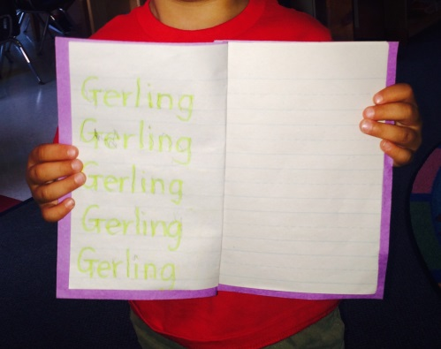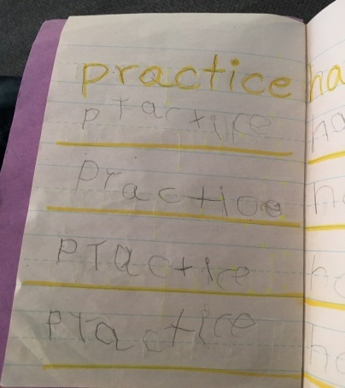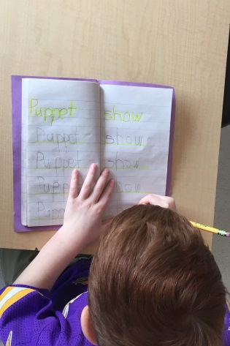
Figure 2: Child writing word “practice”
Figure 3: Child writing “puppet show”
Figure 1: Child tracing his last name

I gave each of the six cases study students an assessment at the beginning of the six month window, and gave them the same assessment at the end of the six month window. This assessment included noting progress of letter sounds, ability to write name, number recognition and written ability of numbers, a self-portrait drawing, and the ability to read or write words. I also sent a survey home (see Appendix C) with parents, asking about their child’s writing and reading habits at home, at the beginning and the end of the six month period. Finally, I kept a record of student activities and sound and letter knowledge for comparative purposes.
Materials:
I used the Montessori materials (See Appendix B) within the classroom, focusing primarily on works that have writing or direct reading and/or writing components within them:
- Sand tray
- Writing name (see Figures 1, 35)
- Sandpaper Letters (See Figures 30,31)
- Movable Alphabet (See Figure 6)
- Metal Insets (See Figures 14, 15)
- Books
- Object boxes (See Figure 13)
- Copying/tracing (See Figures 7, 8, 10, 11)
- Sentence writing
- Journal (See Figure 16)
Procedures:
The children allowed me to photograph their work, and I collected data during our Montessori work time periods. I sent a permission letter home to all the parents in the classroom informing them of my research project, and what I hoped to learn (See Appendix A). In the month of May I noted daily which specific language works were being used within the classroom by our students. The list of works chosen can be found in Appendix B, and I chose works that had a more direct link to reading and writing. I chose to take the observation an hour into our work time to allow students to begin to truly focus on their works, and allow a more authentic view of the materials being chosen. In the month of October, I made the same observations with the same specific guidelines I had prescribed for May. I wanted to compare the two months and see if there were more reading/writing-related works being taken out by the class as a whole due to successive presentations within the area of language.
I chose six students for my case studies, and documented their individual journeys in writing and reading. I gave each child an assessment in the spring of 2015, and then again in October of 2015, to measure their progress. I also sent home a survey (See Appendix C) to the parents of these children, asking some questions related to the child’s reading and writing activities outside of the classroom. I sent this same parent survey home in the fall of 2015 to measure the progress of the child outside of the school environment.
Findings/Results
The results for improvement in reading and writing for the class as a whole was quite positive, as evident from the results of the surveys below:
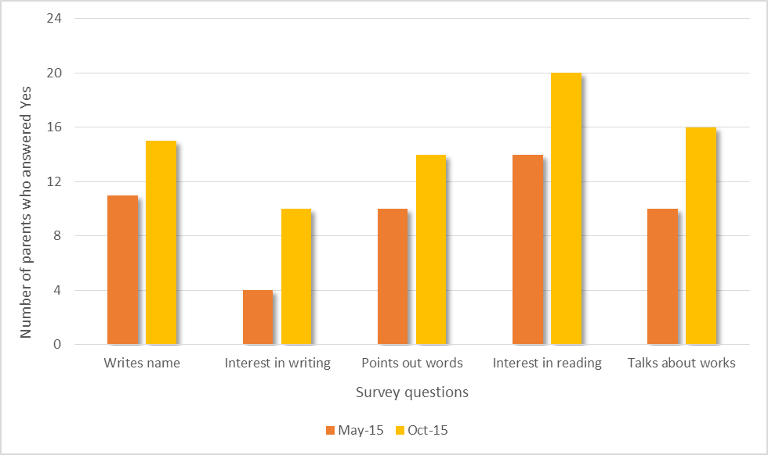
Figure 4. Interest in Literacy
I was pleased to see that the students’ interest or aptitude improved across all of the questions. I also received some very positive feedback from parents. I was particularly interested to see the large growth in the Interest in writing question. I think that the use of the purple books, as well as the time I spent focusing on the importance of writing, seems to have made an impression on the students. Much of the improvement demonstrated in this table must certainly be a result of the children getting older and more in tune with language in general, so this data can’t be taken at face value as scientifically accurate. However I think it is still a worthwhile representation of how presentations have made an impression on the children. Also, the feedback from parents about their children’s level of interest increasing was notable as well as encouraging.
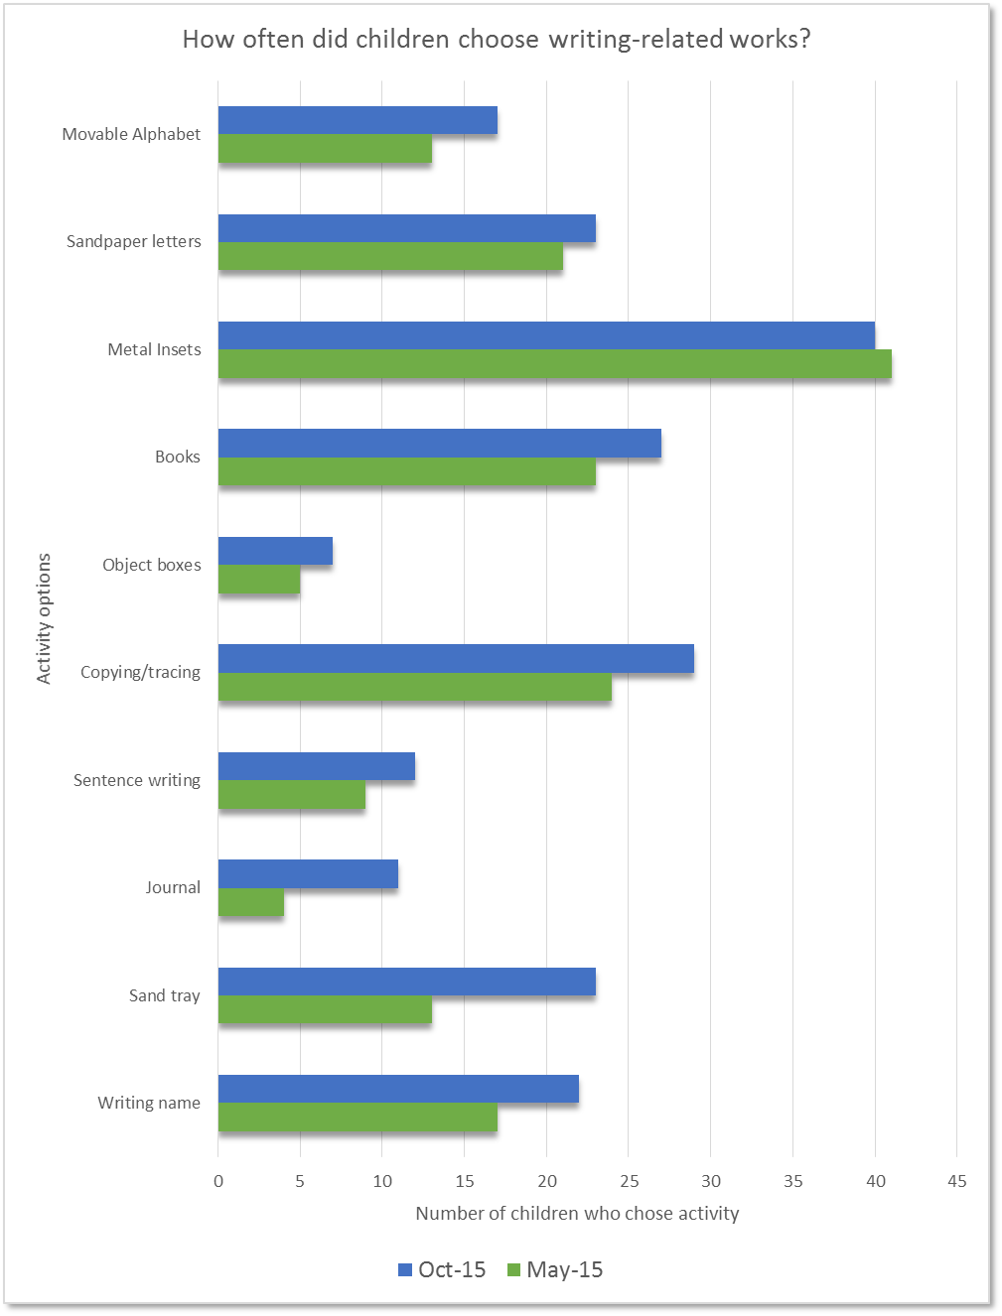
Figure 5. Class Choices in Literacy Related Activities
In the graph above, it was fascinating to see that the amount of times these language works were chosen increased in nearly every category from May to October 2015. I was interested to learn that metal insets were the most popular language works chosen by the children. I am curious if the fact that three people can do this work at the same time lends to the popularity of the work. Students can sit by each other carefully tracing shapes and writing shape names while chatting with their neighbors. The metal insets were also the only work that did not show an increase from May to October. I think this can be explained by the fact that this work was already so popular that there was not much room for growth. Another factor may be that initially the children don’t have the ability/knowledge/facility to work with the rest of the language materials. As this ability increases, and their interest in writing words also increases, the need for metal inset work decreases.
The tracing/copying work, books, and name writing were also popular work in both months. It is interesting to note that the most popular works were ones that all ages of the classroom could use. The sand tray and journal writing work were the two works that increased the most from May to October. The sand tray is a popular work in the classroom for all ages, and the students really got into writing stories and making illustrations to accompany them. This graph illustrates the natural progression Montessori curriculum as the students choose more works with reading and writing components within them, whether consciously or not.

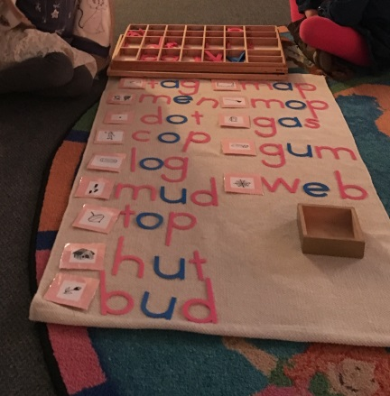
Figure 6. Two children are working on the Movable Alphabet together.
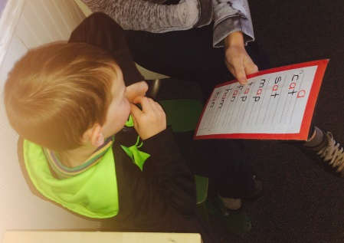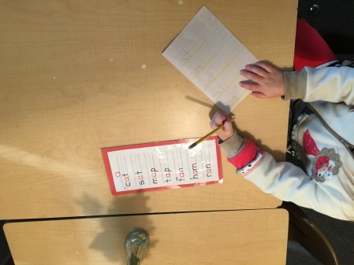
Figure 7b. Child copying three letter words
Figure 7a. Child reading three letter “a” words.

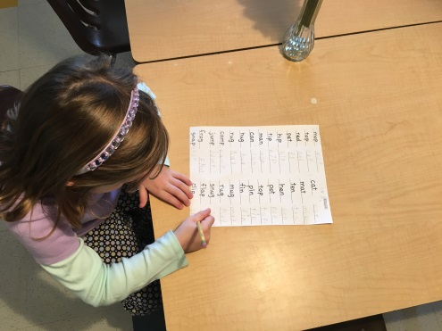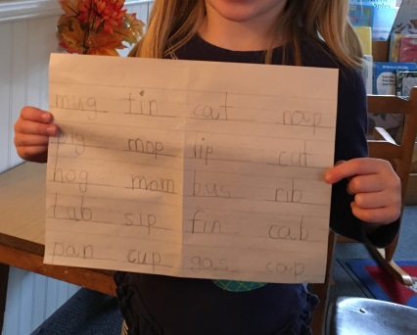
Figure 9. Child is writing three letter works
Figure 8. Child is writing three letter words

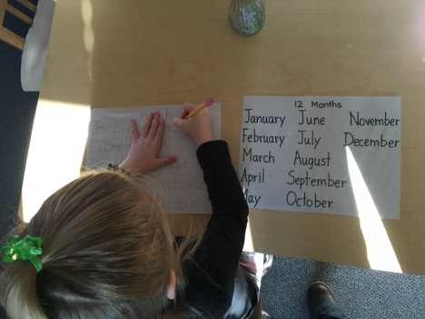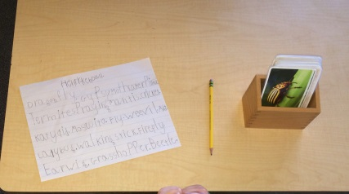
Figure 10. Child is copying names of the months of the year.
Figure 11. Child is writing names of different insects .

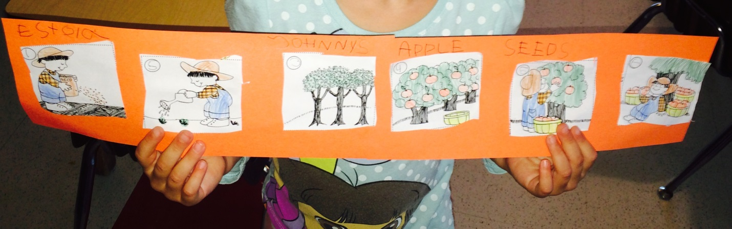
Figure 12. Child is sequencing story about Johnny Apple Seed.

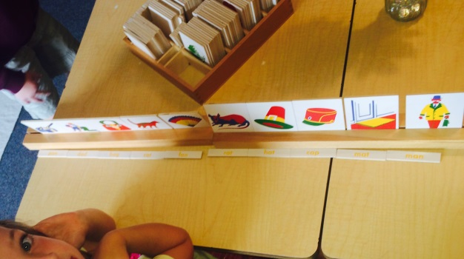
Figure 12. Child is matching picture to three letter words

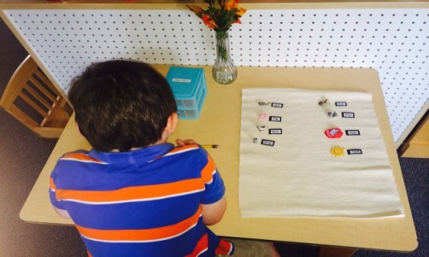
Figure 13. Child is working with Object Box 1

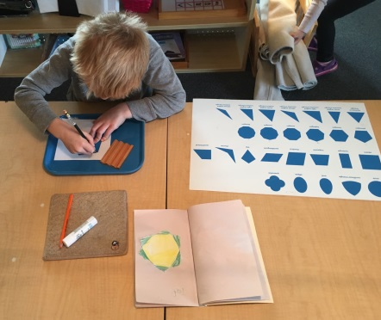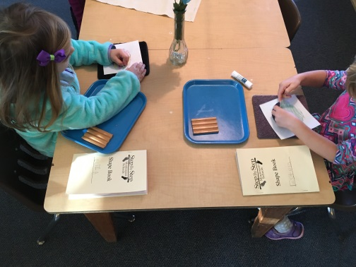
Figure 15. Students work together on their shape book.
Figure 14. Child working on Metal Insets
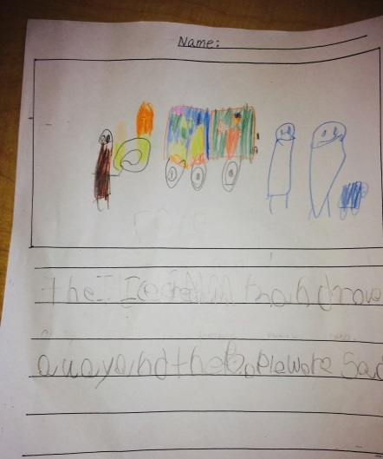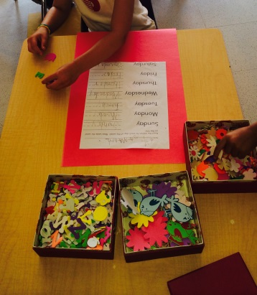
Figure 16. Student writes and illustrates a story
Figure 17. Student is decorating her work with stickers and gel pens

Case Studies
Case Study # 1- 3 year old boy
Spring 2015
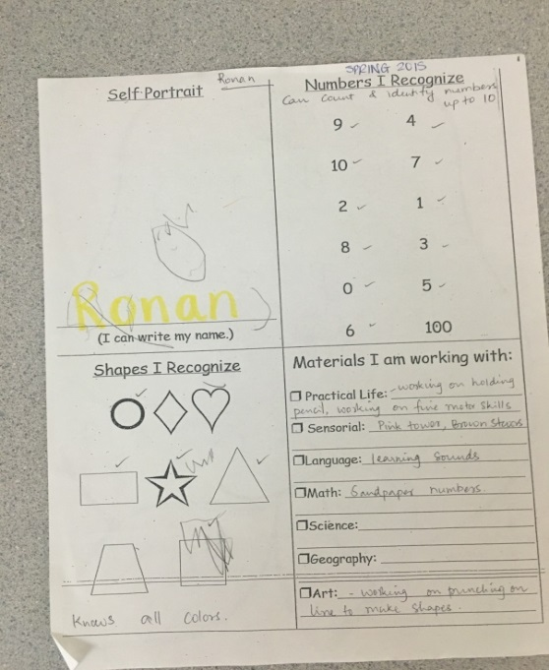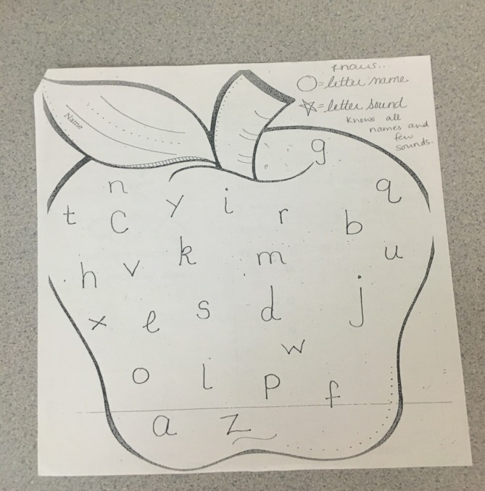
Figure 18. Case Study 1 in spring 2015
Participant A is able to count and identify his numbers up to 10. His self-portrait has a face and eyes, but he has trouble tracing his name. He is working on practical life activities to work on his fine motor skills. Participant A enjoys cutting work, and the sand paper letters and numerals. He has just been shown number rods, and loves to work on his continents map. He also enjoys the pink tower, as well as the brown stairs. Participant A also recognizes and can recite letter names but not the phonetic sounds.
Fall 2015
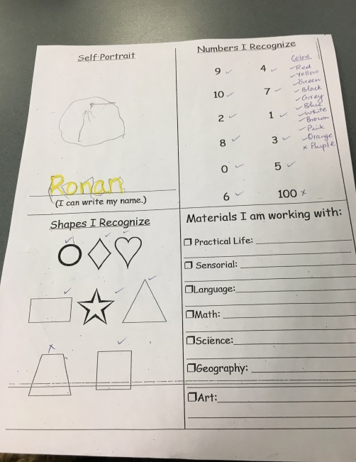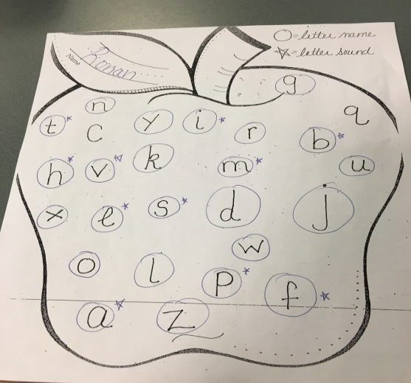
Figure 19. Case Study 1 in fall 2015
Participant A is now able to trace his name successfully, and his self-portrait is a circle with two long lines for eyes. His fine motor skills have improved since spring, aided in part by writing in his purple books. Participant A enjoys working with the sensorial material, and especially enjoys rolling and unrolling a work rug. He loves to take out the pink tower and brown stairs. Participant A is also working on his continent map, and likes working with the science animal puzzles. He also enjoys writing with the chalkboard, and practicing his numbers 1 through 10. Participant A now knows more of the phonetic letter sounds, as he also works with the sandpaper letters daily during work time.

Case study 2- 3 year old girl
Spring 2015
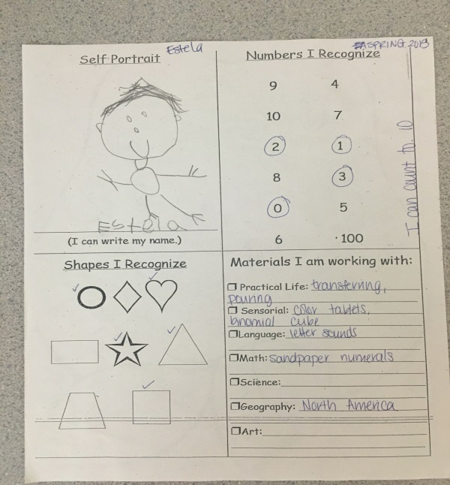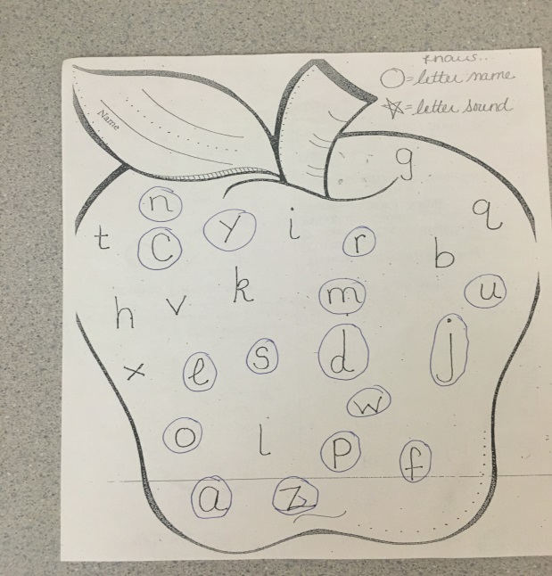
Figure 20. Case Study 2 in spring 2015
Participant B drew a very detailed self-portrait with hair, eyes, mouth, body, feet and hands. She enjoys art, drawing, and coloring in general immensely. She is able to recognize numbers 1, 2, 3, and 0 and can count up to 10. She is working on sandpaper numerals, number rods, and has just finished making her map of the continents. She enjoys the color tablets, binomial cube, and the knobbed cylinders on the sensorial shelf. Participant B also knows many letter names, but does not acknowledge any of the phonetic sounds she knows. Participant B works with the sandpaper letters daily.
Fall 2015
Participant B (now 4 years old) is now able to recognize all her numbers up to ten. She has been recently shown teen boards and is very excited to be doing that work. She has mastered spindle boxes and cards and counters but continues to take this work out as she still enjoys it. Participant B knows all of her phonetic letter sounds and has been working on reading three letter words. She just recently moved up to the first Bob book, and she is so excited to be reading. Participant B is also working on her North America map, and she likes to work with the sandpaper letters with other children who need extra help.
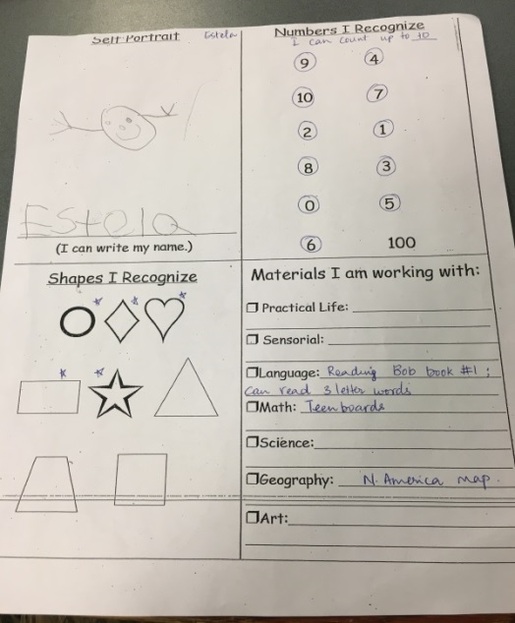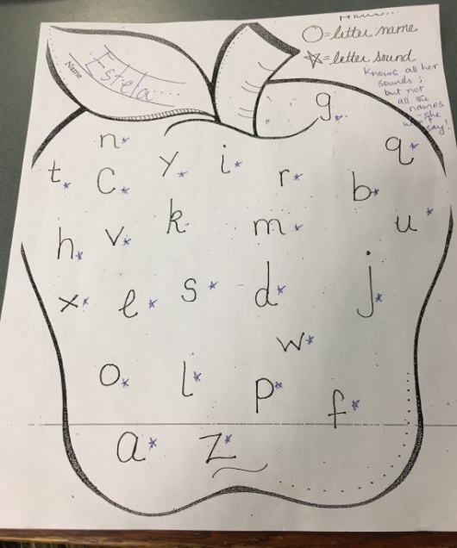
Figure 21. Case Study 2 in fall 2015
Case study 3- 4 year old boy
Spring 2015
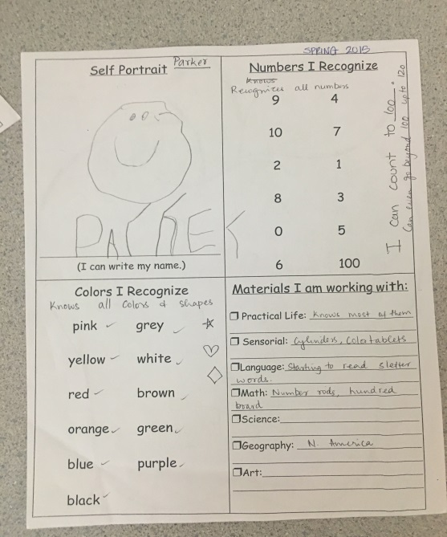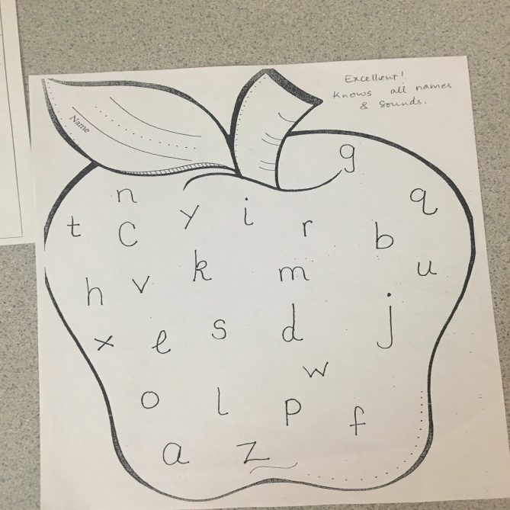
Figure 22. Case Study 3 in Spring 2015
Participant C is able to write his name on his own, and his self-portrait is a circle with eyes and a mouth. Participant A recognizes all his numbers and is able to count up to 120. He knows all his colors and shapes, and enjoys working with the number rods. He enjoys carrying them carefully with two hands and is very purposeful with his work. He also enjoys working with the hundred board, and is starting to read three letter words. He knows all of his phonetic sounds and is working with the movable alphabet. Participant C enjoys working with the knobless cylinders and the color tablets, and his favorite work is the trinomial cube.
Fall 2015
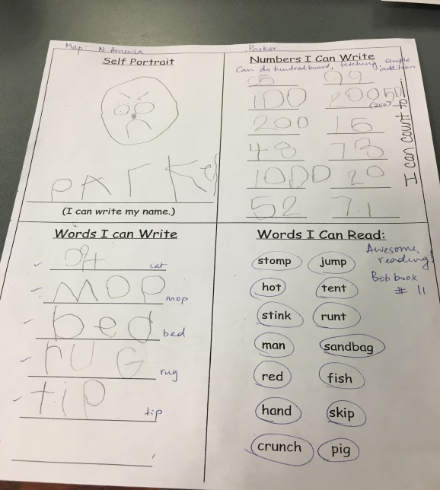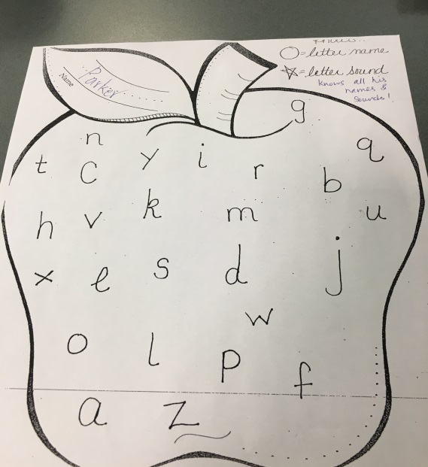
Figure 23. Case Study 3 in fall 2015
Participant C is now working on the addition strip board and simple addition. He loves math, and still continues to take out the hundred board as it is his favorite work. He is also working on the decimal system, and really enjoys the fetching game. Participant C is able to write numbers correctly such as 1000, 52, 71, 15 but wrote 20050 for 250. Participant C is now on Bob Book 11, and his accuracy and ability to link the letters to pronounce the word correctly is amazing. He enjoys reading and likes to sit in the book corner rocking to his favorite book. Participant C is also able to write words correctly such as mop, bed, rug, and tip.
Case Study 4- 4 year old girl
Spring 2015
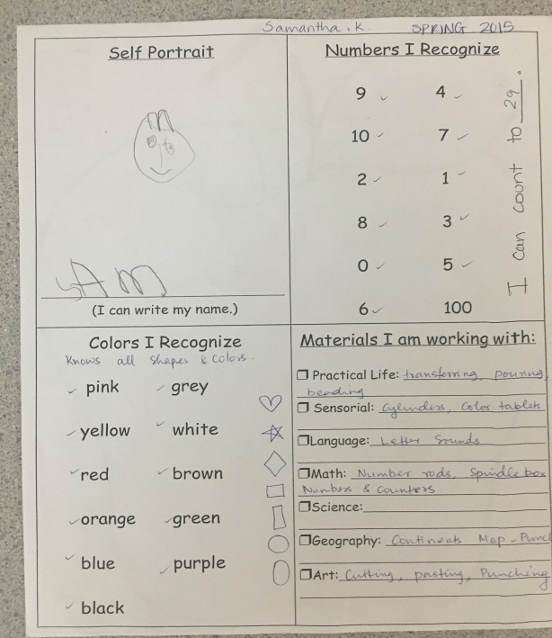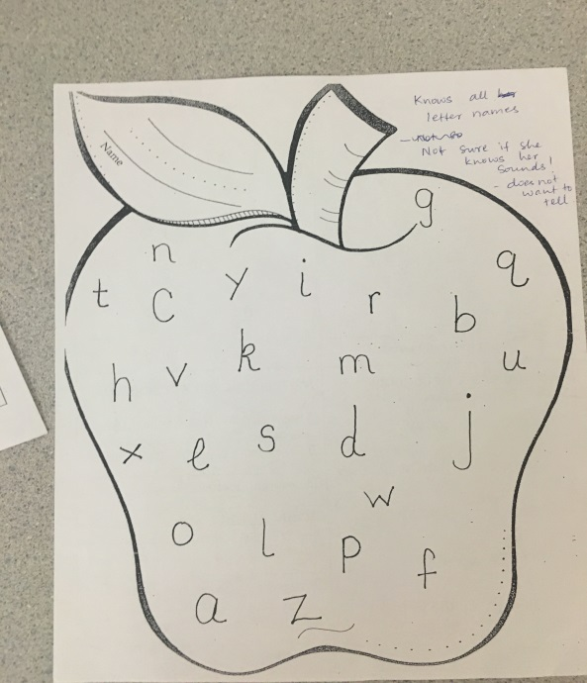
Figure 24. Case Study 4 in spring 2015
Participant D is able to write her name, and create a self-portrait with a face, eyes, nose, mouth, and hair. She is able to recognize her numbers from 0 to 10. She is able to count up to 29, and knows all her shapes and colors. Participant D is very quiet and shy, and although she knew all of the letter names she did not want to tell me how many phonetic sounds she knew. Participant D is working on her letter sounds daily, and is working on cards and counters. She enjoys teaching the younger children the number rods and the spindle box work. Participant D is currently working on making her map of the continents, and enjoys working with the knobless cylinders and the color tablet boxes.
Fall 2015
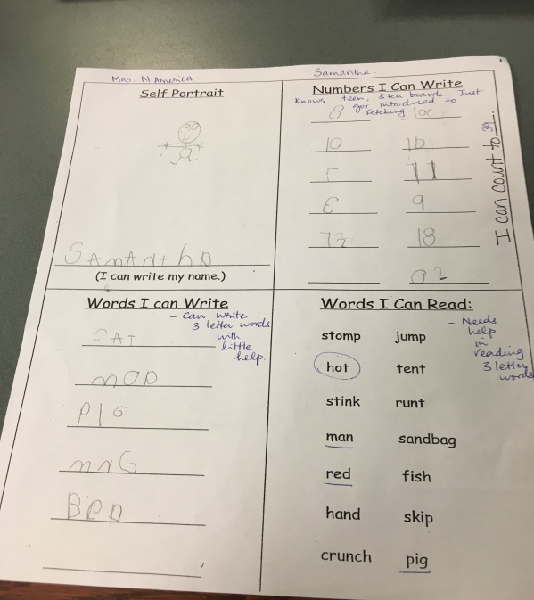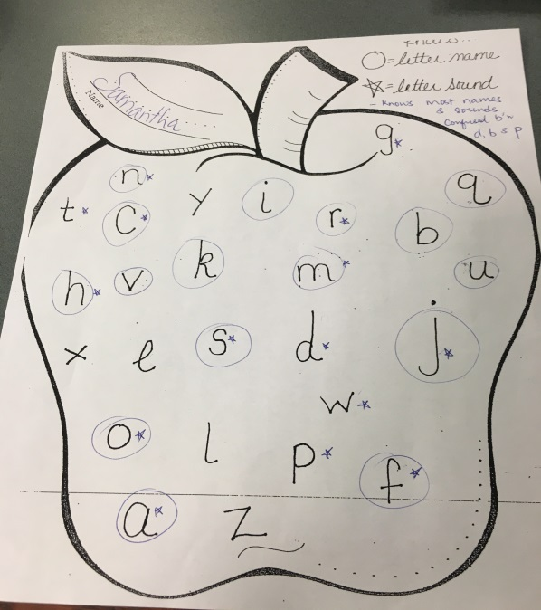
Figure 25. Case Study 4 in fall 2015
Participant D is now able to write her full name, and her self-portrait includes a body, feet and hands. She has mastered her teen and ten boards, and has just been introduced to the decimal system and the fetching game. She is able to write numbers correctly such as 10, 18, 11, and 100 and is able to count up to 39. Participant D is now able to write three letter words with some help, as she has learned the phonetic sounds of the alphabet. Examples include pig, bed, map, and cat. Participant D is learning her North America map and enjoys art projects as well as cutting and pasting. She has mastered the movable alphabet and is ready to start reading Bob books, a series of children’s books designed to teach reading skills acquisition

.

Case Study 5- 5 year old boy
Spring 2015
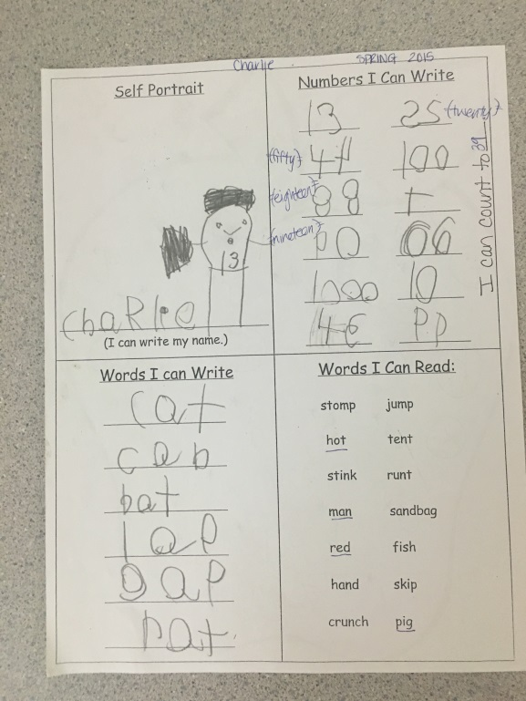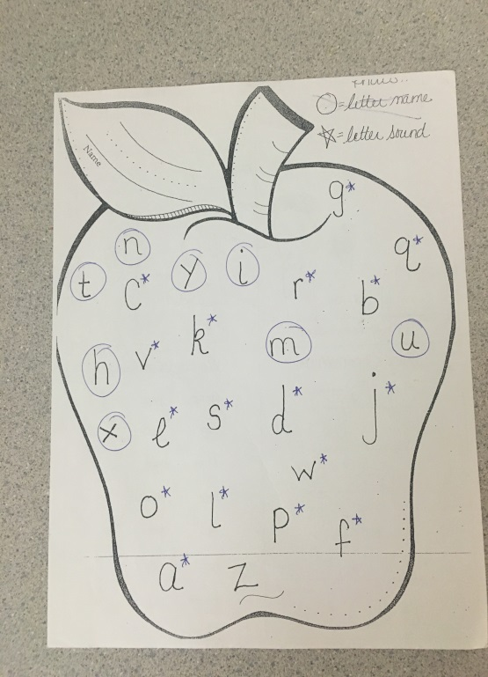
Figure 26. Case Study 5 in spring 2015
Participant E is able to write his name, including emphasizing the dot on the i as part of his signature. His self-portrait has a face, body, hands and feet and hair. There is detail in his picture and a number 13 within the face. Participant E knows all his letter sounds and is able to write three letter words such as cat, gap, rat, bat, and cab with some help. He works with the movable alphabet often, and enjoys working with the object boxes. Participant E is able to write numbers but working on directionality of the numbers. He can count up to 39, and is working on his North America Map. Participant E has mastered teen and ten boards, and enjoys working with the hundred board. He has recently been shown the decimal system and loves the fetching game. Participant E is on the second Bob books, and is proud to be reading and sounding out words.
Fall 2015
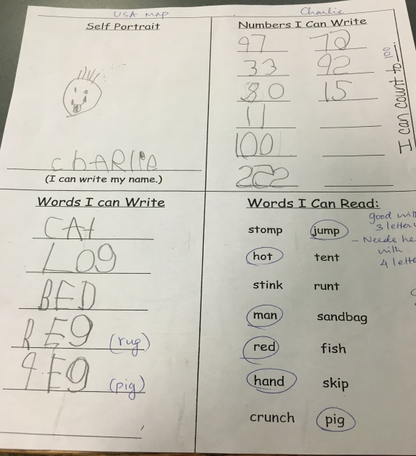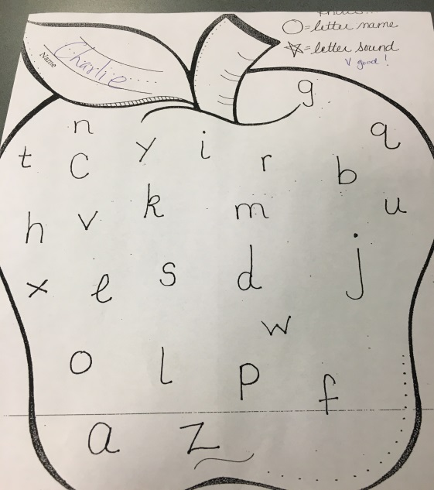
Figure 27. Case Study 5 in fall 2015
Participant E is able to write double digit numbers with more numbers facing the correct direction. He is now able to count up to 100, and can write three letter words without help. Participant E is able to read three letter words with ease but has some trouble with four letter words. He is working on his United States map, and is very close to learning all the states. Participant E is working on addition, fetching, and is ready to be shown subtraction. He enjoys being a role model in the classroom, and loves to help the younger children with works he has already mastered. He enjoys writing stories but worries about the correct spelling. Participant E still enjoys working with the knobless cylinder boxes and the fabric work on the sensorial shelf.

Case Study 6- 5 year old girl
Spring 2015
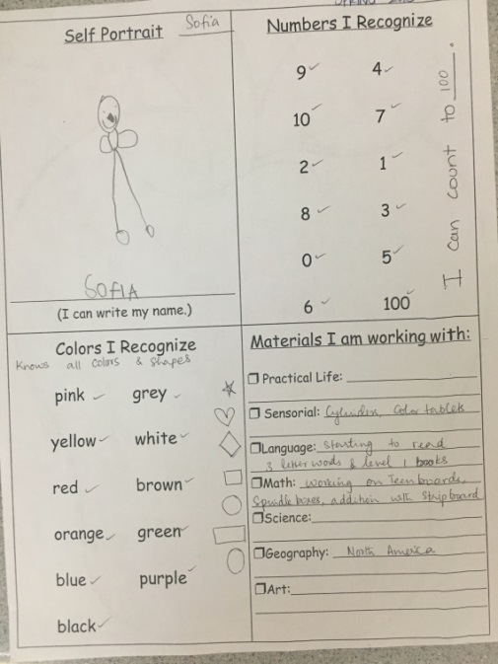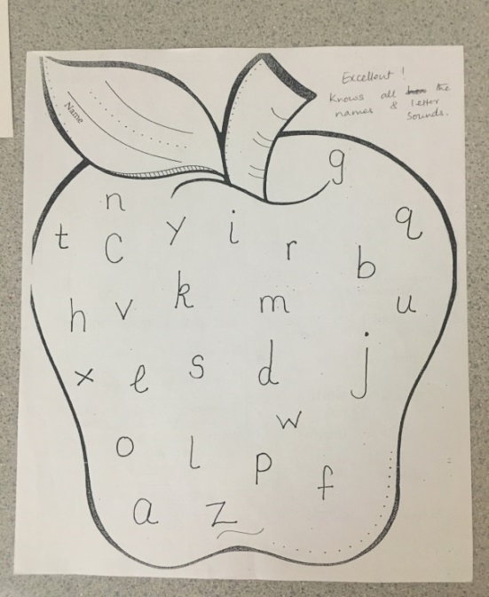
Figure 28. Case Study 6 in spring 2015
Participant F is able to write her name and her self-portrait includes a face, body, hands and legs. She knows her numbers, and can count up to one hundred. She is working on teen and ten boards, and has just been shown addition with the strip board. Participant F enjoys working with the knobbed cylinders and the color tablet boxes. She is working on her North America map and is very close to knowing all of it. She is starting to read three letter words and level 1 books. Participant F enjoys working with her younger friends and teaching them the correct way to use their works. Participant F loves to work with the color tablet box 3 and the trinomial cube. She enjoys writing and copying words.

Fall 2015
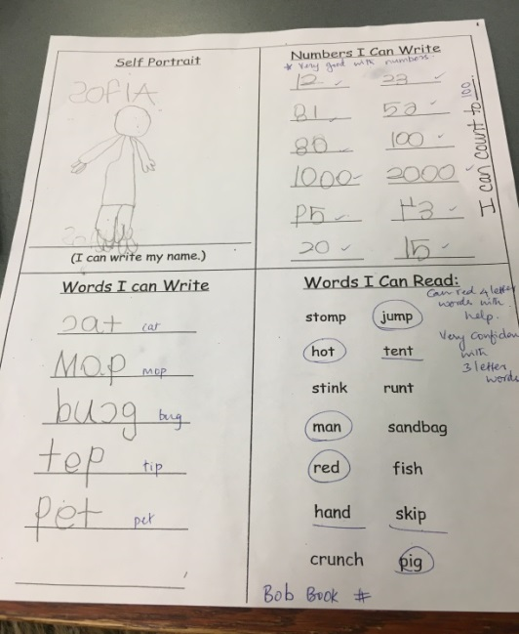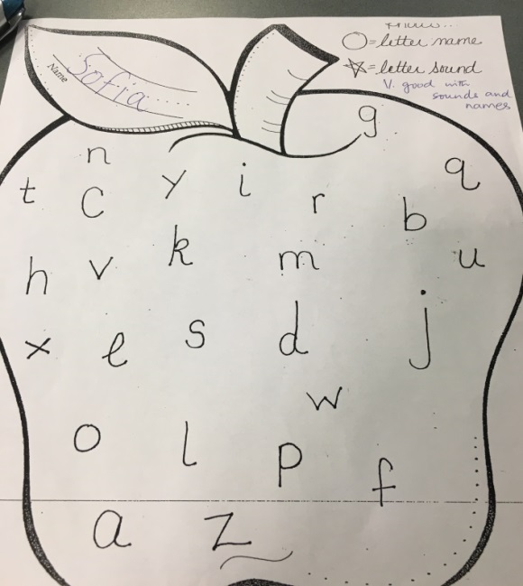
Figure 29. Case Study 6 in fall 2015
Participant F is able to write her name but still continues to write her S backwards. Her self-portrait has more realistic arms and legs and is wearing clothes. The hands have fingers and detail is shown within the drawing. Participant F is able to count to 100, and is very good with writing numbers such as 2000, 43, 20, 75. She can write three letter words independently, and can read three letter words with ease. Participant F is working on reading four letter words and is on the second set of Bob books. She enjoys being a leader and a role model for the younger children in our classroom, and is always willing to help a friend. Participant F enjoys writing stories and illustrating her work. Participant F also enjoys working with the metal insets and creating beautiful shapes with the work.

Interpretations/Discussion-
My six case studies illustrated the journey of going from writing to reading, and I was able to document their progress. I observed these children for six months, and by choosing a pair of three, four, and five year olds of opposite genders I was able to compare among all of the age and gender demographics in my classroom. It was interesting to note that there were certain things that were different for each of the 6 children, and other things that were uniform among all of them.
One of the things that I noticed which was consistent among all of the students was the fact that each and every one of them made significant progress in both their writing and reading. Also notable among them all was that the process did not feel forced. It was self-initiated, and proceeded at each child’s own natural pace. For each of them the first thing they wanted to do (for some of them this precedes my case studies) was to write their name. This was the case for each of them, as well as all the other children I have taught. I think this relates back to the fact that what they are writing needs to have meaning as well as some level of connection to their world. I have also discussed how much it helps when the child feels a sense of ownership of the words they write. The desire to write their names is certainly appropriate, then, given that it is the one word that they “own”. Finally, the last thing I observed to be consistent among all of the children was the deep sense of pride they take in both the words they write as well as words that they read. I came to realize that this is a driving force in their language development.
Just as there were traits which were common all of the students, there were also aspects which were different for each of them. The point at which each child passed the developmental milestones for reading and writing varied greatly. In a traditional school this might be cause for embarrassment or concern, but the Children’s House is such a cooperative and non-competitive environment, that each milestone is a joy, no matter how long it took to reach. This is part of the power of Montessori—that the learning is completely individualized, accommodating each child based on where they are developmentally rather than setting guidelines for them based on their ages. This study also showed me the extent to which various Montessori works can be extended to incorporate reading or writing components. Going forward I plan to explore ways to extend various works in order to incorporate multiples subjects.

Conclusion/Discussion
My central question when conducting this action research was to learn why it is more effective to teach writing before reading, and how the Montessori materials and curriculum foster this process. My observations and the analyzed data suggest that introducing writing before reading does prove to be effective. The successive nature of the materials and the ease in which it is presented allows for success each time they are given a new challenge within the classroom. They take pride and ownership in their work, and the sheer joy of doing the work is the sole reason it was chosen. I was able to document and watch the journey of my six case studies, and their aptitude and understanding of writing and reading increased greatly. My observations and data gathering allowed me to understand that writing is necessary before introducing reading because it is an efficient and successful way to start children on their reading journey. The beauty of the Montessori curriculum is the ease with which language learning takes place and how unconscious the child is of the fact that they are learning to read and write. In my case studies, it seemed as though one day the child was not reading and the next day they were. I was able to watch the child transcend from writer to reader by introducing appropriate materials at the appropriate time.
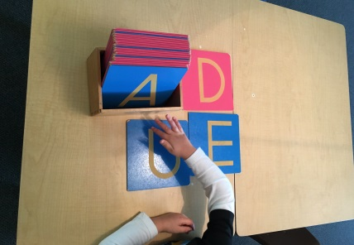
Figure 30.
This child is using the sand paper letters to practice his capital letter sounds.
Figure 31.
The child decided to match the upper case sand paper letters to the lower case sand paper letters in order of the alphabet
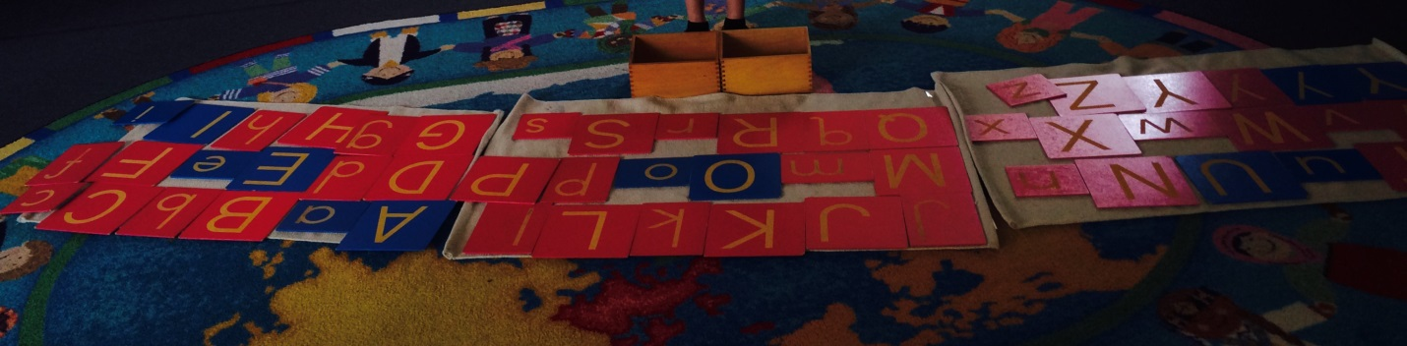
The sandpaper letters allow the child to fulfill a sensory need and connect the sense of touch and sound so the child is able to associate the phonetic sound with the sight of the letter. I found that the children enjoyed working with the sandpaper letters even though they already knew their sounds. They also enjoyed working with younger friends who needed help.
How can a child write before they know how to read? A child is simply given the exposure and opportunity to write at an early age, and combined with practical life works and exposure to the sandpaper letters, the children begin to write. Although their letters don’t make words, they are practicing the skill of writing and recognizing the letters of the alphabet and connecting the phonetic sounds attached to the letter.
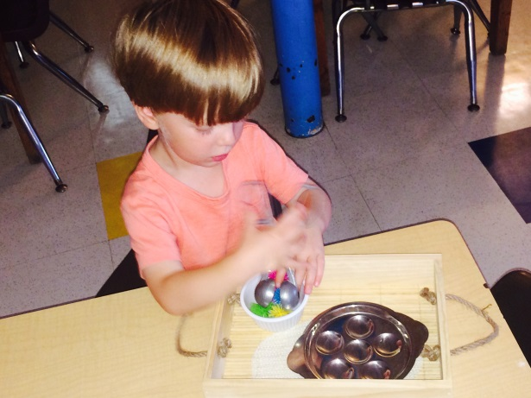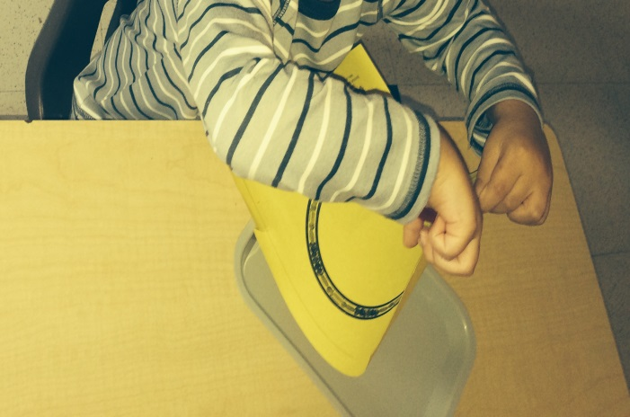
Figures 32 and 33. These children are working on their fine motor coordination with a practical life tong work, and cutting work.
During this exposure to writing, Maria Montessori noticed in her observations that her students experienced an explosion of writing, and even if the child couldn’t read they could not stop writing. Figures 34, 35, 36, and 37 show examples of students exhibiting signs of explosion of writing:
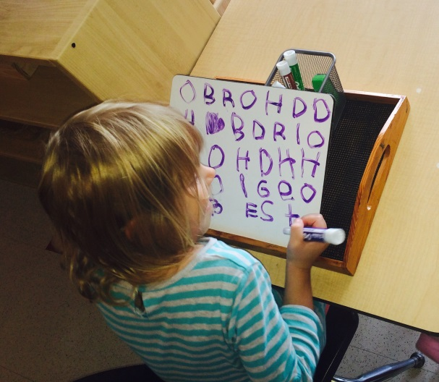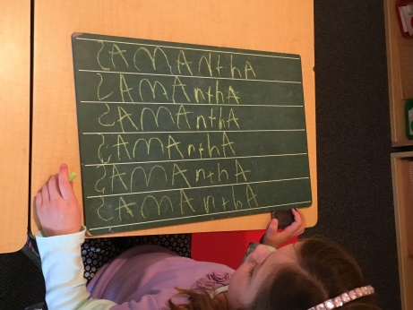
Figure 35. Child is practicing writing her name on chalkboard
Figure 34. Child is using whiteboard to write letters

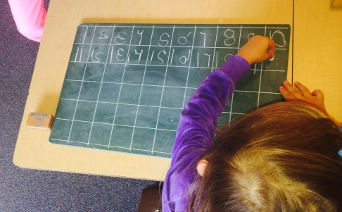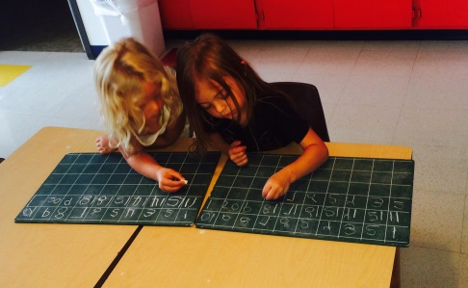
Figure 37. Two children work together to practice writing their numbers
Figure 36. Child is writing her numbers

As the children are shown more presentations about reading and writing, do they choose more reading and writing works on their own? The data that I took from the months of May and October showed an increase in choosing works that had a direct reading or writing component to it. This could be due to the successive presentations within the Montessori curriculum. The parent surveys also mentioned an increase in their children wanting to read or write, as well as talking about reading and writing.
Do the Montessori materials relating to reading and writing work for children of all age groups? This concept is the intended nature of the Montessori children’s house. The younger students are able to see the older students reading and writing, which gives them incentive to want to read and write also. The organic nature of the material and the independence of the program allow the child to work at their own pace allow the child to be successful each time. The younger students are cutting and pasting, choosing practical life works and sensorial materials, unaware that they are practicing reading and writing already. The introduction of the purple books allows all students the opportunity to write daily and improve their fine motor skills.
How does early writing benefit their long term development?
Early writing benefits each child’s academic long term development because it sets them up for success in their future advancing academics. The students learn to read and write in a no-pressure atmosphere and are allowed to work at a pace that is comfortable for them, allowing them to experience the love of learning. This love of learning is also part of the key to how Montessori children are able to read and write effortlessly and unconsciously.
Action Plan/Implications for further research
I learned so much watching my students over these last six months. It was great to see how much each child grew and matured over these six months and it was especially interesting to gauge my six case studies and analyze their progress. I would be interested to take this study further and analyze six case studies who are taught to read before they could write. Since this time I did not have control data for comparison, I’d like to compare the two sets of data. This research study also made me realize that all the Montessori materials can be extended to incorporate some form of reading or writing within them. I picked certain materials that directly related to reading and writing, but many of the materials in other subjects could incorporate these components as well.
Unfortunately I was not able to answer my fourth question via quantifiable or qualitative data, which was whether early writing benefits a child’s long-term development. This would require a longer-term study, and even tracking children after they leave their Montessori school. It is something about which I am very curious, but I don’t have the resources to carry out this investigation on my own. Overall I feel that I learned a lot from this process, and it will definitely add another dimension to my writing and reading presentations.

References

Dunn, Sharon Elise, Assessing Students’ Writing: A Six Traits Approach, Montessori Life, 2000, 12 (3), 37-39.

Graham, Steve. Want to Improve Children’s writing? Don’t Neglect Their Handwriting, Education Digest, 2010, 76(3), 49-55.
Johnstone, Susan, Creative Writing for Early Elementary, Montessori Life, 2001, 13 (4).48-49.
Lawhon, Tommie, Cobb, Jeanne B, Routines That Build Emergent Literacy Skills in Infants, Toddlerss, ,and Preschoolers, Early Childhood Education Journal, 2002, 30(2), 113-118.
Montessori, Maria (1967) The Discovery of the Child. New York: NY: Random House Publishing Group.
Ohlhaver, Dorothy, Preludes to Writing in Early Childhood, Montessori Life, 2001, 13(4), 36-37.
Reid, Laura, Follow the Poet: Poetry in the Montessori Classroom, Montessori Life, 2009, Issue 3, 16-23.
Richardson, Sylvia Onesti, The Montessori Preschool: Preparation for Writing and Reading, Annals of Dyslexia, 1997, 47, 241-256.
Soundy, S. Cathleen, Portraits of Exemplary Montessori Practice for All Literacy Teachers, Early Childhood Education Journal, 2003, 31(2), 127-31.
Stewart, Roger A,, Rule, Audrey C., Girodano, Debra A., The Effect of Fine Motor Skill Activities on Kindergarten Student Attention, Early Childhood Education Journal, 2007, 35(2), 103-109.

Van Kleeck, Anne; Schuele, C. Melanie, Historical Perspectives on Literacy in Early Childhood, American Journal of Speech-Language Pathology, 2010, 19 (4), 341-355.

Woods, Carol S. Building a Stairway to Literacy with the Montessori Movable Alphabet,
Montessori Life, 2002, 19-24.
Zeece, Pauline Davey, Learning, Literacy, and Literature in Children’s Social World, Early Childhood Education Journal, 2002, 30(2), 119-124.

Appendix A

Dear Parent/Guardian,
I am currently working on my Master’s degree at the University of Wisconsin, River Falls. As part of my degree, I have chosen to create a research project illustrating the advantages and importance of introducing language (reading and writing) at an early age. I will be using student samples as evidence in my study, and am asking for your permission to allow me to use your child’s work. I will also be monitoring your child’s progress throughout the year to support my hypothesis.
The information in this research will be kept confidential, and your child's participation in this project is completely voluntary. Only those children who have parental permission and who want to participate will do so, and any child may stop taking part at any time. You are free to withdraw your permission for your child's participation at any time and for any reason without penalty.
If there are any questions at any time about the study or the procedures, please contact:
Molly Van Wagner
Director of Research, UWRF
(715) 425-3195 or email molly.van-wagner@uwrf.edu
And/or Professor Gay Ward (715) 425-0601 gay.ward@uwrf.edu
I am more than happy to share the results and findings of my research with participant families. I am looking forward to the opportunity to conduct my research using your child as a participant.
I agree to allow my child _____________________ to participate in Tahzeem Ryan’s research project for 2015.
If you want your child to participate in this research project, please sign on the line below.
Parent/Guardian’s Printed Name | Signature | Date
Appendix B
__________ 2015 Week:_________
Works and activities | Monday | Tuesday | Wednesday | Thursday | Friday
Movable Alphabet
Sandpaper letters
Metal Insets
Books
Object boxes
Copying/tracing
Sentence writing
Journal

Sand tray

Writing name

Appendix C

Parent Survey
(All data will be used anonymously)

Yes | No
Yes | No
Yes | No
Yes | No
Yes | No
- My child is able to write his or her name legibly.

- My child shows interest in writing when at home (i.e. has journal or asks for paper).

- My child points out words they see in their environment.

- My child shows interest in reading (even if they are not able to read).

- My child talks about reading or writing works they do at school.

