CRISIS STOP™ AMS Member SCHOOLS
(833) 519-4357
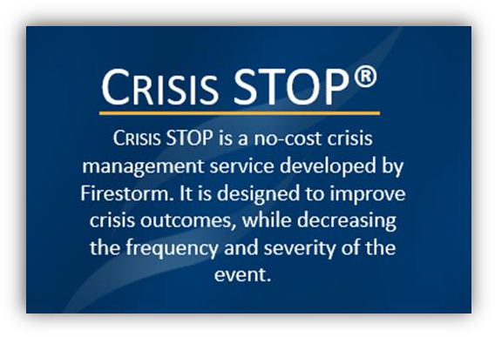
CRISIS STOP® SCHOOLS
CRISIS STOP® is a 24/7, no-cost one hour service that Firestorm provides to AMS member schools. During a crisis, seconds count. Actions and words matter.
Organizations feel an overwhelming compulsion to act and speak. Very often, these initial inclinations are wrong, and result in additional exposure and liability. Firestorm can help. By providing the first hour of consultative support at no cost, the barrier of making the call as early as possible is lowered, due to the elimination of an immediate financial commitment.

CRISIS STOP provides the services necessary to:
Stabilize the situation
Trigger appropriate resources Opine on the exposures Prevent common crisis errors

This initial, no-cost CRISIS STOP consultation slows the process, controls panic, identifies the immediate concerns, provides direction, and lays the foundation for consequence management. More importantly CRISIS STOP will prevent many common mistakes, thereby reducing frequency, severity, and brand and reputation damage.
Through CRISIS STOP, you will have access to an experienced Firestorm Crisis Coach®, who has managed real crises. This early intervention will prevent many common crisis errors and can significantly improve outcomes. You are under no obligation to continue Firestorm services after the initial one-hour consultation.
The Firestorm CRISIS STOP® hotline (833) 519-4357 can be called at any time. Recent crises that Firestorm has handled include:
- ACTIVE SHOOTER
- ABUSE
- BULLYING
- CHILD PORNOGRAPHY
- CYBER BULLYING CYBER STALKING
- DRUG/ALCOHOL ABUSE
- FIRE
- HAZING
- HEALTH ISSUE/COMMUNICABLE ILLNESS
- HIGH-PROFILE STUDENT
- INAPPROPRIATE STAFF-STUDENT RELATIONSHIPS
- KIDNAPPING
- LOSS OF FACILITY/FIRE/FLOOD/TORNADO
- MISSING CHILD
- NON-CUSTODIAL PARENT
- SEXTING
- SEXUAL ABUSE
- SEXUAL HARASSMENT
- SEVERE WEATHER
- SOCIAL MEDIA ATTACKS
- SOCIAL MEDIA RISK- BRAND/REPUTATION
- SUICIDE
- TERRORISM
- TRANSPORTATION ACCIDENT
- VIOLENCE
- WATER/FOOD CONTAMINATION
- WORKPLACE VIOLENCE; DOMESTIC VIOLENCE
- WILD ANIMAL

