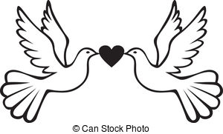

March for Peace Lyrics by Frank Leto www.frankleto.com

Step by step let’s march for peace.
Come and join us won’t you please.
Peace can be a dream come true.
Here are things we all can do:

Be kind to other people.
Help someone in need.
Uplift the world with love
By doing good deeds and maybe one day?

Random acts of kindness.
Say no to violence.
Show someone compassion,
Make a difference and maybe one day?

Step by step let’s march for peace.
Come and join us won’t you please.
Peace can be a dream come true.
Here are things we all can do.

Honor Mother earth.
Respect all living things.
Take a walk in nature,
Feel the joy it brings and maybe one day?

Care for our planet.
We can’t let down our guard.
Gaze up at the night sky
And count your lucky stars and maybe one day?

Step by step let’s march for peace
Dr. Montessori would be pleased
Peace can be our dream come true
And it all can start with you
maybe one day, Yes maybe one day we’ll have peace

